**How to Use @Initbinder in Spring MVC.**

**How to Use @Initbinder in Spring MVC**:

In Spring MVC architecture, controller is used for processing the web request and rendering the response to the View.

Now, @Initbinder comes into picture if we want to customize the request being sent to the controller. It is defined in the controller, helps in controlling and formatting each and every request that comes to it. This annotation is used with the methods which initializes WebDataBinder and works as a preprocessor for each request coming to the controller.

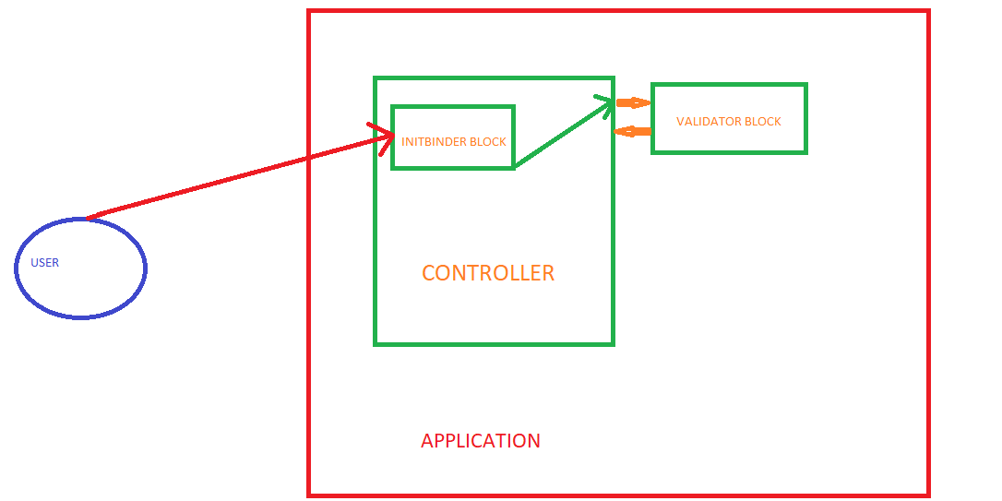

**InitBinder interaction with other Components**

<https://medium.com/bridgecrew/how-to-use-initbinder-in-spring-mvc-ecb974a6884>

How to Use @Initbinder in Spring MVC.